# How to Set the Custom Objects Layout

## Lightning

1. Navigate to Object Manager on Setup, go to Leadspace Company Data - page layout and insert the Leadspace informative fields and the LS fields to the custom object layout, do the same on Leadspace Person Data.

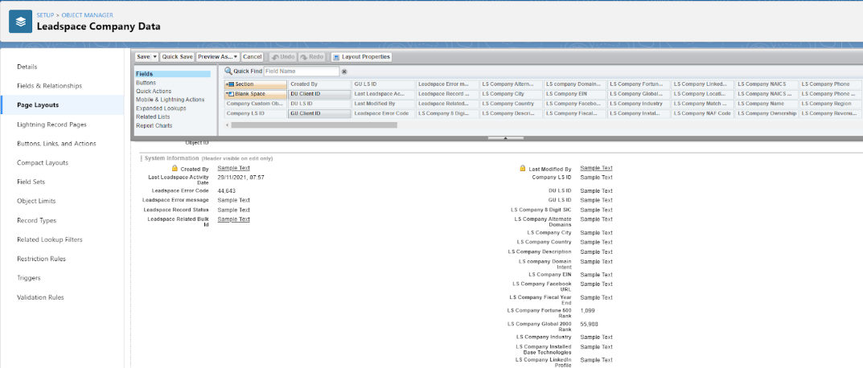

On the related list, standard objects can be linked - Account to Company, Contact, and Lead to Person:

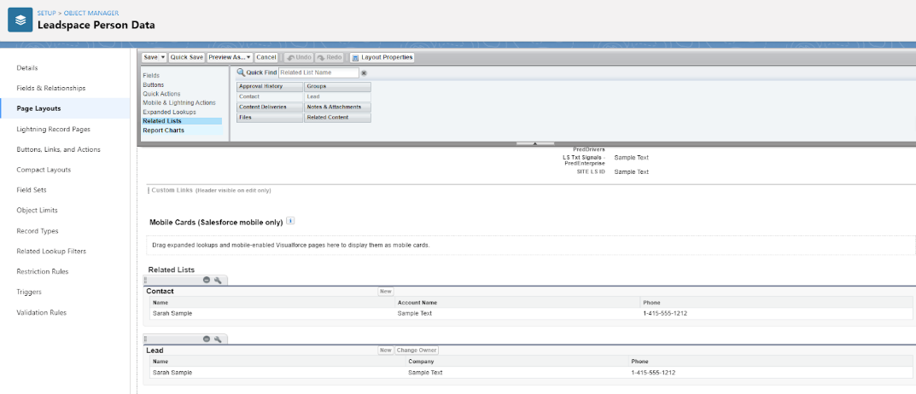

2. On the Object Manager, go to the standard objects and add the lookup field to the layout - Leadspace Company Data field to Account layout and Leadspace Person Data field to Lead/Contact.

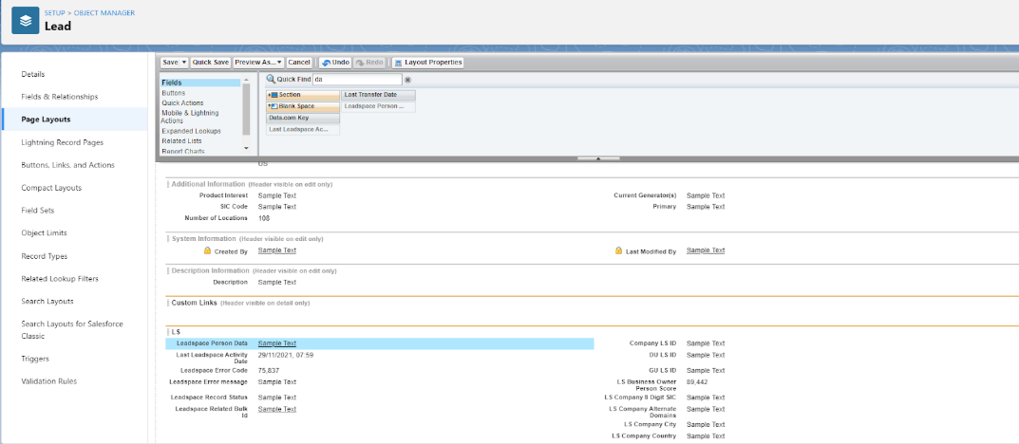

3. On the Object Manager, go to Sync Activity Bulk object, on page layout choose related lists and add Leadspace Companies Data and Leadspace People Data. On each list, click Properties and add the Leadspace Record Status field.

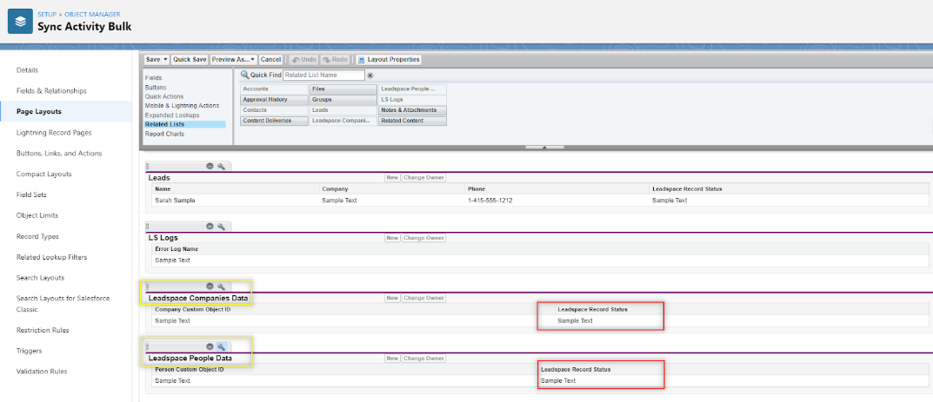

## ______________________________________________________

### ‘Nice to have’ Layout

There’s an option to add a custom object tab (relevant to classic view only)

1. Go to any standard record and on Setup click Edit Page
2. On Tabs click ‘Add Tab’
3. On the new tab, click the tab label ‘custom’ and name it. Click Save.
4. On the new tab drag the Related Record component
5. Click Edit Lookup Field and choose the first lookup -  ‘Leadspace Company Data’, and the second lookup - ‘Use This Company_Data_c’.

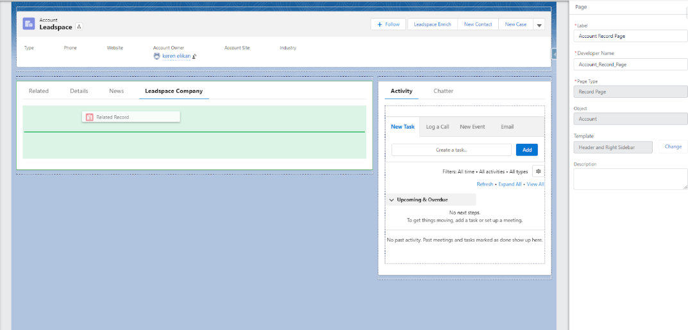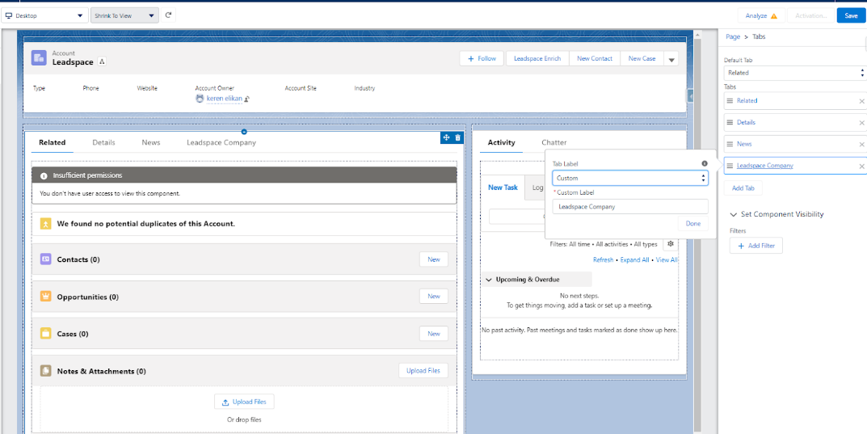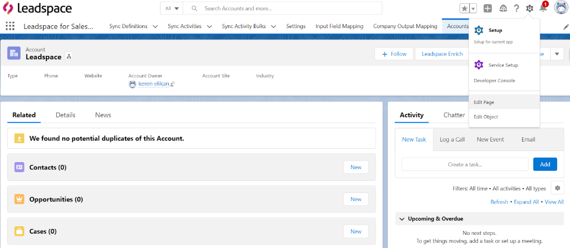

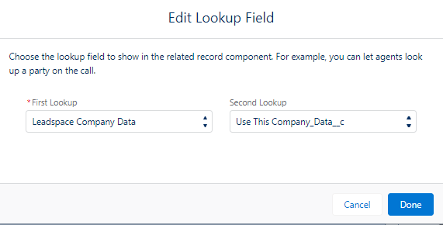

6. Then click ‘New Update Action’

7. Create new action to update a record

8. Add the fields you wish to see on the Action Layout and click save (Note: Salesforce recommendation is maximum of 8 fields).

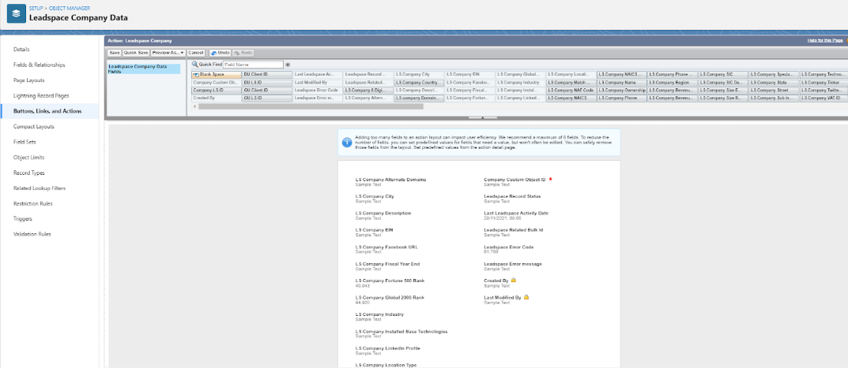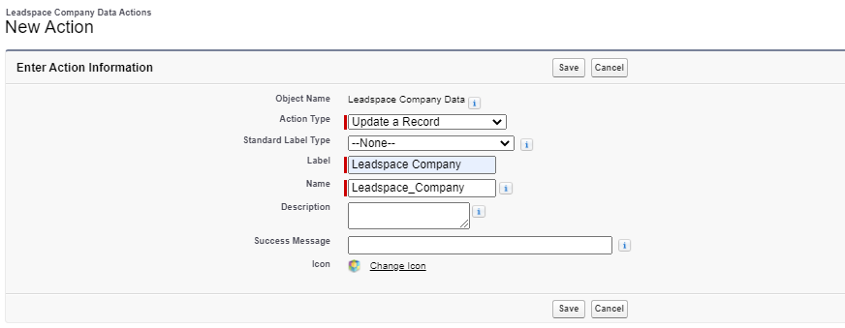

9. Click Edit Lookup Field and choose Leadsapce Company Data



10. On the Update Action, choose the action you created to update a record.

11. Click Save and activate.

12. After enrichment, custom object data is a tab on the standard object.

